So we start with nmap which gives us a few open ports specific to Active Directory.

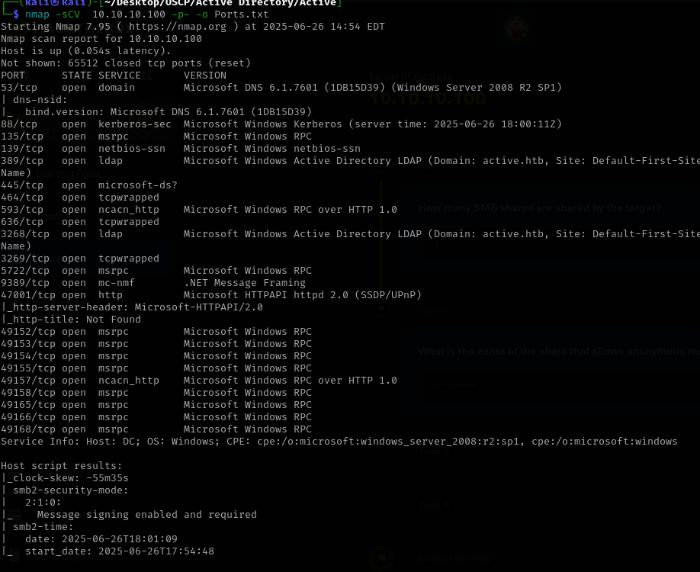

Then we use crackmapexec to enumerate smb shares and their permissions.We use crackmapexec smb 10.10.10.100 -u “” -p “” –shares.The blank values means anonymous login.We notice Replication with READ permission for anonymous login.
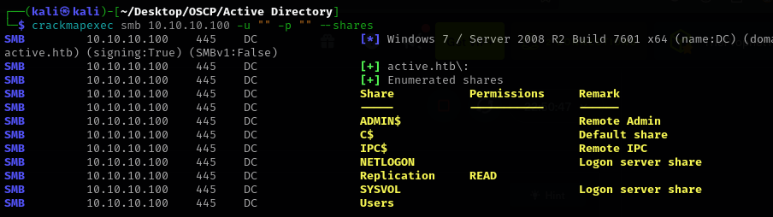

Using smblclient we managed to get inside the open share.
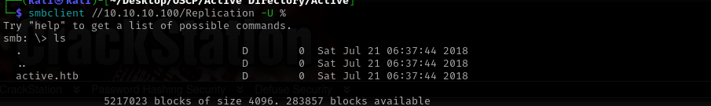

After quite some enumeration, we’ve found Group Policy Object which contained Groups.xml
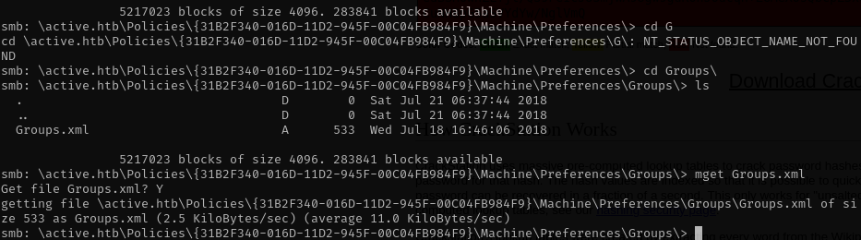

Downloading and opening this file revelead something that looks like an encrypted pass.
After doing some research, I’ve found that the password is AES-256 encrypted and used “gpp-decrypt” to crack it.Also we have an username along with that password.
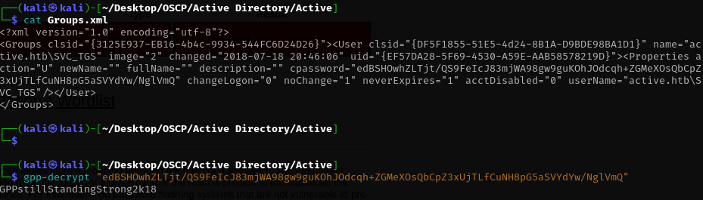

Back to crackmapexec, now with an username and password.
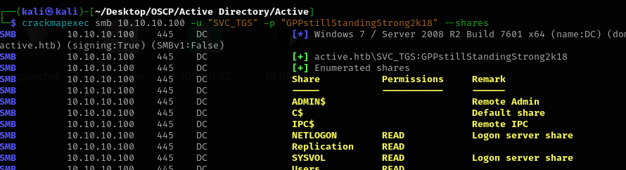

It looks like we can access other shares, I’m particularly interested in Users share.
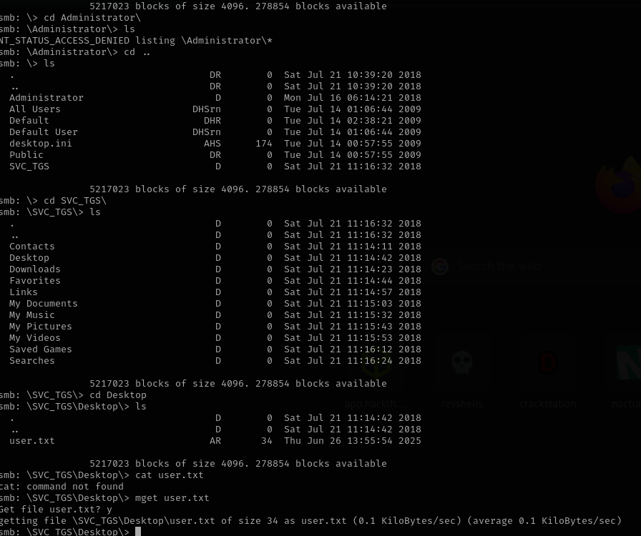
Using smbclient, authentificated with the username and password got us the user flag.

Now we need to get to a more privileged user.
We can try Kerberoasting with Impacket.
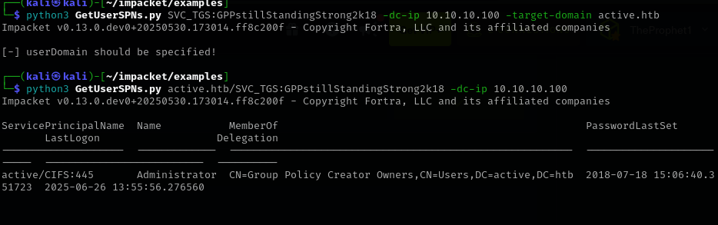

I’ve used impacket GetUserSPNs.py in order to list possible users which we can kerberoast.It looks like we found the most privileged user, the administrator.
Next we modify the GetUserSPNs.py command in order to request the administrator password hash, which we then crack with hashcat.
A neat little information that I’ve found is that if the time of the attacking machine is not close to the time set on the target machine, the kerberoast will fail so, we use “sudo timedatectl set-ntp true” in order to set the time correctly and then we get the password hash.
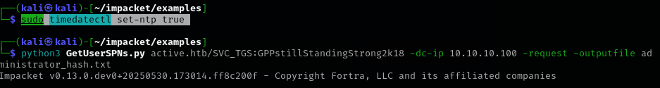
Using hashcat is pretty straightforward and it get’s us the password.
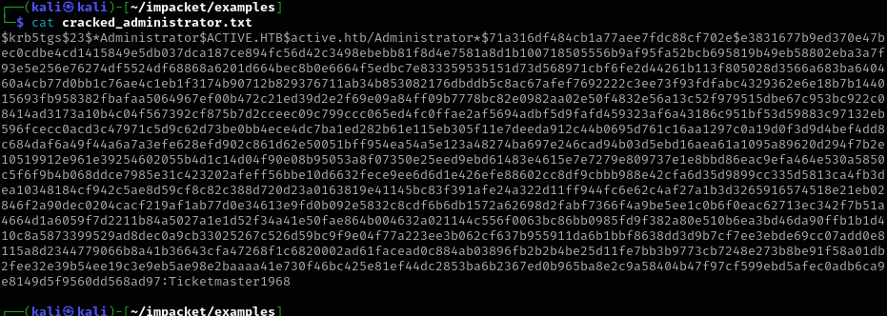
Back to smbclient and we are inside with the Administrator user.The root.txt is located under Administrator/Desktop.
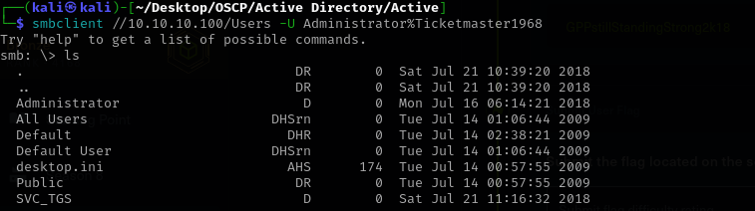

Let's recap the entire process we just completed, step-by-step:
- Anonymous SMB Login & GPP Reconnaissance:
  - You started by performing an anonymous smbclient login to the Replication share on 10.10.10.100 (smbclient //10.10.10.100/Replication -U %). This was successful, allowing you to browse the share.
  - You navigated through the directories within the Replication share, specifically into a Group Policy Object (GPO) path that led to active.htb\Policies\{...}\MACHINE\Microsoft\Windows NT\.
  - Within this path, you likely found an XML file (e.g., Groups.xml, Services.xml) containing a cpassword.
- GPP cpassword Decryption:
  - You extracted the cpassword string (edBSHOwhZLTjt/...) from the XML file.
  - You used gpp-decrypt (or noted its use) to decrypt this password, revealing the plaintext password for the SVC_TGS user account (GPPstillStandingStrong2k18). This gave you legitimate domain credentials.
- Kerberoasting Target Identification (via SPN Enumeration):
  - Using the newly acquired SVC_TGS credentials, you attempted to use impacket/examples/GetUserSPNs.py to enumerate Service Principal Names (SPNs) in the active.htb domain.
  - This step successfully identified a critical SPN: active/CIFS:445, which was associated with the highly privileged Administrator account. This identified the Administrator account as a prime target for Kerberoasting.
- Time Synchronization Fix (Addressing KRB_AP_ERR_SKEW):
  - When trying to request the Kerberos ticket, you encountered a common Kerberos error: KRB_AP_ERR_SKEW(Clock skew too great). This indicated a significant time difference between your Kali machine and the Domain Controller.
  - You resolved this by synchronizing your Kali machine's time with sudo timedatectl set-ntp true, which fixed the time skew issue.
- Kerberoasting Execution (Hash Extraction):
  - After resolving the time synchronization, you re-ran python3 GetUserSPNs.py with your SVC_TGS credentials, specifying the target domain (active.htb) and using the -request -outputfile flags.
  - This successfully authenticated to the Domain Controller and requested the Kerberos Service Ticket (TGS) for the active/CIFS:445 SPN. The hash contained within this ticket was then saved to administrator_hash.txt in a crackable format.
- Hash Cracking with Hashcat:
  - Finally, you used hashcat with mode 13100 (for Kerberos 5 TGS-REP etype 23 hashes) and the rockyou.txt wordlist to attack the hash in administrator_hash.txt.
  - Hashcat successfully cracked the hash, providing you with the plaintext password for the Administrator account in the active.htb domain.

